

KURO – Information for invitation to tender

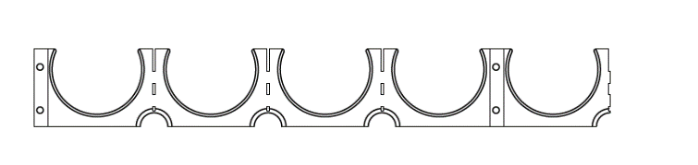
Product:

PP Spacers 5 – lined
For smooth pipe / one sided

Information for invitation to tender:

 | Pos:....................... | PP Spacers one sided for 50 mm
 |  | Cable protection pipe / 5-lined / System KURO o. glw.
 |  | (www.kuro-kunststoffe.de), supply and install,
 |  | as an addition to pos: ...........
 |  | Amount:............Pieces UP: ....... TP: ........

 | Pos:....................... | PP Spacers one sided for 110 mm
 |  | Cable protection pipe / 5-lined / System KURO o. glw.
 |  | (www.kuro-kunststoffe.de), supply and install,
 |  | as an addition to pos: ...........
 |  | Amount:............Pieces UP: ....... TP: ........



